# **MINI PROJECT REPORT**

### on

**CAREER DEVELOPMENT**

**Submitted in partial fulfilment for the completion of BACHELORS OF ENGINEERING., VI Semester**

**ARTIFICIAL INTELLIGENCE & DATA SCIENCE**

**By**

P.SAILAJA(20ND1A5486)

P.RAMYA(20ND1A5487)

P.UMA MAHESWARI(20ND1A5489)

P.ARUNDHATHI(20ND1A5490)

Y.LAVANYA(20ND1A54E2)

**Under the guidance of MS. K .KAVYA**

**H.O.D**

**G.ASHOK**

**Dept. of CSE, STMW.**

**ST.MARY’S WOMEN’S ENGINEERING COLLEGE(STMW)**

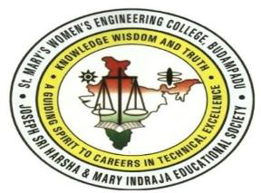

### In partial fulfilment of the requirement for the award of degree of

### BACHELOR OF COMPUTER SCIENCE ENGINEERING(AI&DS)

**CERTIFICATE**

This is to certify that the Mini Project-IV entitled “**CAREER DEVELOPMENT“** submitted to **ST.MARY’S WOMENS ENGINEERING COLLEGE ,** in partial fulfilment of the requirements for the completion of B.E., VI semester Artificial intelligence and Data science, during the academic year 2022-2023, is a record of original work done by P.SAILAJA,P.RAMYA,P.UMA MAHESWARI,P.ARUNDHATHI,Y.LAVANYA during the period of study in the Department of CSE, STMW, GUNTUR, under my supervision and guidance.

### Project Guide Head of the Department

**MISS.K .KAVYA Dr . G ASHOK**

Professor & Head, Dept of CSE,

STMW,BUDAMPADU. STMW,BUDAMPADU.

# DECLARATION

We the undersigned solemnly declare that the project report is based on our own work carried out during the course of our study under the supervision of Mr. D Jayaram. We certify that: The portrayal of the book recommendation web application is original and has been done by us under the general supervision of our supervisor. The work has not been submitted to any other Institution for any other degree/diploma/certificate in this university or any other University of India or abroad. We have followed the guidelines provided by the university in writing the report. Whenever we have used materials (data, theoretical analysis, and text) from other sources, we have given due credit to them in the text of the report and giving their details in the references.

P.SAILAJA(20ND1A5486)

P.RAMYA(20ND1A5487)

P.UMA MAHESWARI(20ND1A5489)

P.ARUNDHATHI(20ND1A5490)

Y.LAVANYA(20ND1A54E2)

# ACKNOWLEDGEMENT

We would like to express our special thanks to our teacher Miss K. Kavya who gave us the golden opportunity to do this mini project titled ‘CAREER DEVELOPMENT’ which helped us learn new skills regarding HTML and CSS as well as web technologies . It also helped us apply the knowledge we have gained to practical use. We would also like to thank our parents, family and friends without whom this project could not have been completed.

**ABSTRACT**

It is not easy to decide on the career option that will determine the rest of each student’s life especially when they are in **class 10**. It does not help them as even parents are left confused about the right advice to offer. The confusion a student faces is varied and huge in nature. They will be doubtful about which group they opt to choose and even which degree to pursue after their completion of schooling and whether it must be done regularly or in correspondence.

So, [**Career Guidance After 10th**](https://www.merementor.com/career-counselling-after-10th-12th)gives confidence to students in order to choose the right career after their completion of board examinations. There won’t be any necessity to panic or become anxious even if they have scored lesser marks in it. The matter of fact is that in today’s generation of self-starters, the number of options open to students is several and varied. It is not recommended to make unplanned, hasty decisions dues to parental/peer pressure. It is significant to pursue a field that a student is usually **passionate**about.

Students should seek career guidance as early as class 10th and 12th. After everything, having to choose between commerce and science is an essential factor in simplifying the career after **class 10**. The course of study after this class may be more **generalized**, but they are significant in giving a student a solid foundation for career courses after schooling. Doing the research in advance can save students a lot in life.

Choosing the right **career after class 10** may be challenging as there are plenty of options available. Career counselling with a trained career counsellor can assist students to solve all their problems. A career counsellor makes use of the career assessment to estimate a perfect career path for the student’s future. So, a career assessment test analyse their interests, skills, abilities, and a clear road map is provided based on all these.

**TABLE OF CONTENTS**

CERTIFICATE ii

DECLARATION iii

ACKNOWLEDGEMENTS iv

ABSTRACT v

LIST OF FIGURES vii

INTRODUCTION

Introduction 1

Application 1

Motivation 1

Problem statement 2

Aim and objective 2

SYSTEM REQUIREMENTS

Functional requirements 3

Non-functional requirements 3

Software requirements 3

Hardware requirements 5

METHODOLOGY

Architecture 6

UML Model 7

Assumptions 8

Requirements 8

IMPLEMENTATION 9

RESULT AND TESTING 25

CONCLUSION AND FUTURE SCOPE

Conclusion 30

Limitations 30

Future Scope 30

BIBLIOGRAPHY 31

**LIST OF FIGURES**

Block diagram of project 6

flow of project 7

**INTRODUCTION**

**INTRODUCTION**

Career development is the support an organization provides to employee professional growth, especially to employees' movement to a new position or project within the organization. This support often includes coaching, mentoring, skills development, networking and career pathing.

**APPLICATION**

Career development increases employee motivation and productivity**.** Attention to career development helps you attract top staff and retain valued employee. Supporting career development and growth of employees is mandated by the Philosophy of Human Resources Management

**MOTIVATION**

Career counseling is nothing more than assisting individuals in making their own decisions to establish, change, and improve their careers for a prosperous future. In a nation such as India, career counseling is a broad field. It conducts workshops for individuals pursuing vocations after the 10th and 12th grades. Then, it is for those who are seeking employment. Career counseling reveals the student's abilities and skills about what he wants to become in the future. The primary objective of counseling is to encourage students to maintain ambitious goals. It prepares students to make sound judgments and eliminates their career-related anxiety.

**PROBLEM STATEMENT**

To create a Career Development system, is efficiently recommends courses to students based on their interests that they have to built their own career, and provide them insight on the various courses that they were recommended.

**AIM AND OBJECTIVE**

The primary aim and objective of the project is to enable a quick and easy way through which students can choose their own path based on given the multiple courses that we provide on our project.

**SYSTEM REQUIREMENTS**

**FUNCTIONAL REQUIREMENTS**

A career development web application that can be easily accessed by anyone. It does not require any login making it much more accessible and easy to use. The Students needs to choose their courses that they have to study, and based on their interest. Once the list of courses have been given to the students that they have to choose and know about the courses, the student can click on the interested course to know more information about it such as its syllabus, duration, colleges, job opportunities .This provides more insight to the students why they are choosing their courses. In addition, the students can also see the set of courses that are available in our project .

**NON FUNCTIONAL REQUIREMENTS**

Once the project is deployed, since media queries are used, the website can be easily accessed on any device such as a laptop, or phone, or tablet. This makes the project portable. Furthermore, since our website does not take any personal or confidential information from the user, it is secure. The website has very low maintenance.

**SOFTWARE REQUIREMENTS**

Web technologies like HTML (Hyper Text Markup Language), CSS (Cascading Style Sheet), and flask were used for providing the front end . HTML is used for describing the structure of the website. It is a basic document needed for building any website. It consists of a series of elements which tell the browser how to display the content of the website. CSS is a language used for describing how html elements will be displayed on the screen of any media.

Microsoft Notepad is a word processing tool included with Windows. You can use it to create a log-type file that adds the current date and time each time the Notepad file is opened. Here's how to create a log file in Notepad

Select **Start**, enter **Notepad**, and select it from the results. Type .LOG on the first line, and then press ENTER to move to the next line. On the File menu, click Save As, type a descriptive name for your file in the **File name** box, and then click OK. When you next open the file, note that the date and time have been appended to the end of the log, immediately preceding the place where new text can be added. You can use this functionality to automatically add the current date and time to each log entry.

**HARDWARE REQUIREMENTS**

The hardware required for building this project is quite simple. To implement any software project, one requires a computer on which the project can be run and thus be used. A Windows PC and Windows 7 as the operating system was used for developing this project as it is stable and Releable.

**METHODOLOGY**

**BLOCK DIAGRAM**

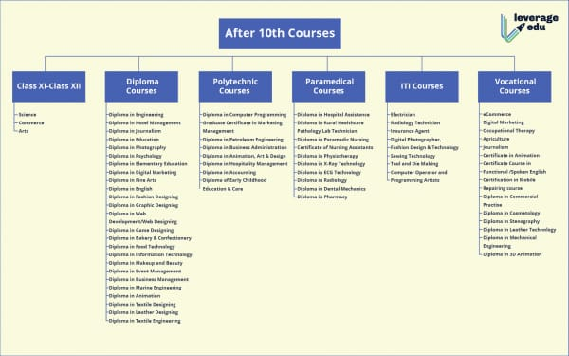

To build a Career Development , we first need to click on be unique button then the new page will opened. Here we will see top 10 courses in that page. In this list of courses the related information will also be showed.

**ASSUMPTIONS**

It does not require any login making it much more accessible and easy to use. The Students needs to choose their courses that they have to study, and based on their interest

**REQUIREMENTS**

The user should have access to a web browser such as Google Chrome, Mozilla Firefox, Internet Explorer or any other web browser, along with a good internet connection to use this website, on their phone, or PC.

**IMPLEMENTATION**

<!DOCTYPE html>

<html>

<head>

<title>My Home Page</title>

<style>

body {

background-image: url('https://thumbs.dreamstime.com/z/colored-pencils-white-background-concept-study-creativity-colored-pencils-white-background-concept-study-110222024.jpg');

background-size: cover;

background-repeat: no-repeat;

}

header {

text-align: center;

padding: 50px;

color: white;

text-shadow: 2px 2px black;

}

main {

display: flex;

flex-direction: column;

align-items: center;

padding: 50px;

}

button {

padding: 10px 20px;

margin: 10px;

background-color: pink;

border-radius: 5px;

border: none;

font-size: 16px;

}

</style>

</head>

<body>

<header>

<h1><button><a href=MS.HTML>TOP BEST COUNTRIES FOR MS</button></h1>

<h1><button>AFTER 10th COURSES</button></h1>

</header>

<main>

<p><button><a href =DIPLOMA.HTML>DIPLOMA</button></p>

<p><button><a href=INTER.HTML>INTERMEDIATE</button></p>

<p><button><a href=POLYTECHNIC.HTML>POLYTECHNIC</button></p>

<p><button><a href=PARAMEDICAL.HTML>PARAMEDICAL</button></p>

<p><button><a href=ITI.HTML> ITI </button></p>

<p><button><a href=VOCATIONAL.HTML>VOCATIONAL COURSES</button></p>

**TESTING AND RESULTS**

A user defined function Career Development is written that takes in the title of the project as a parameter. The Student can choose their interested course by clicking on their interested courses. The primary aim and objective of the project is to enable a quick and easy way through which students can choose their own path based on given the multiple courses that we provide on our project.



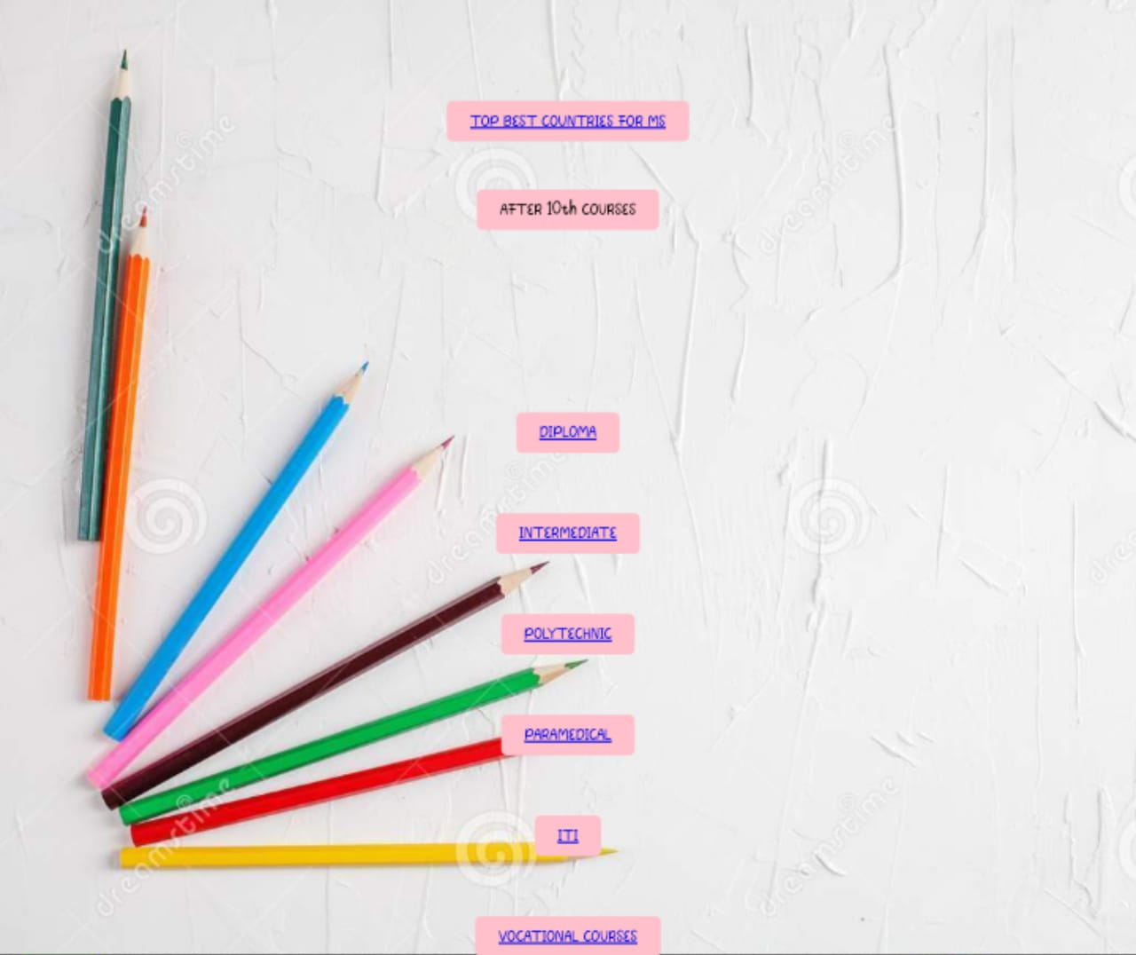

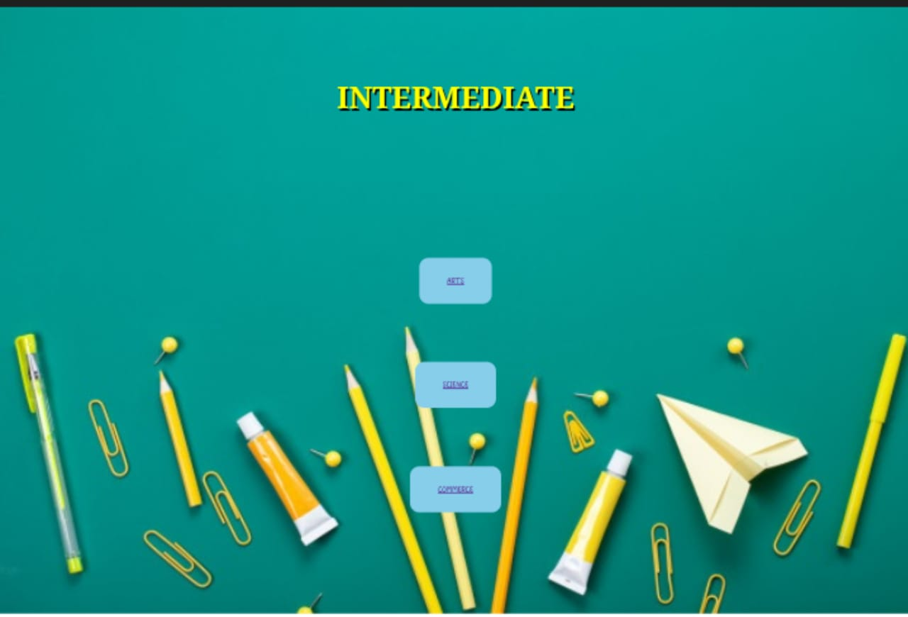

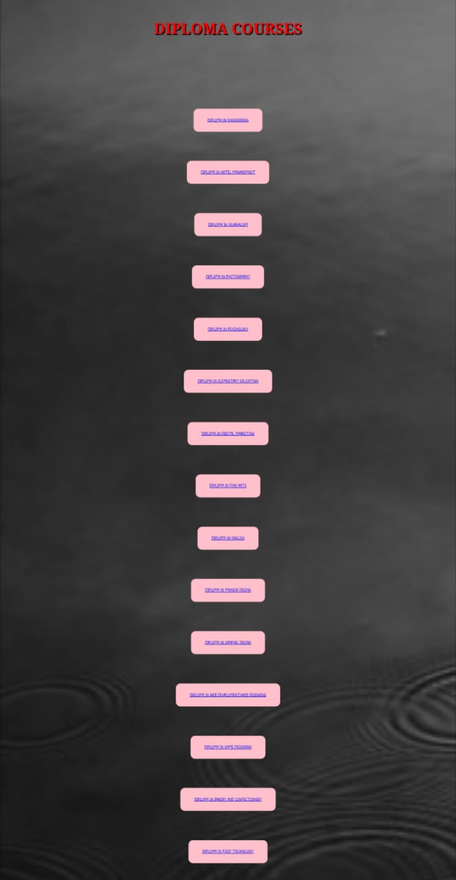

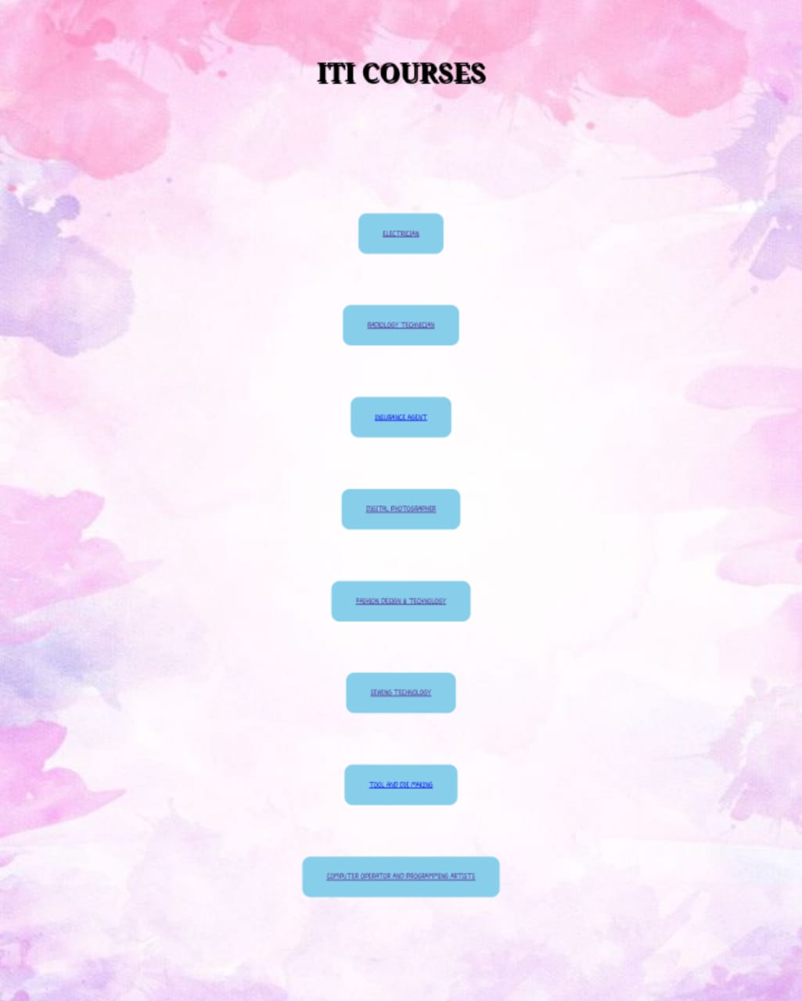

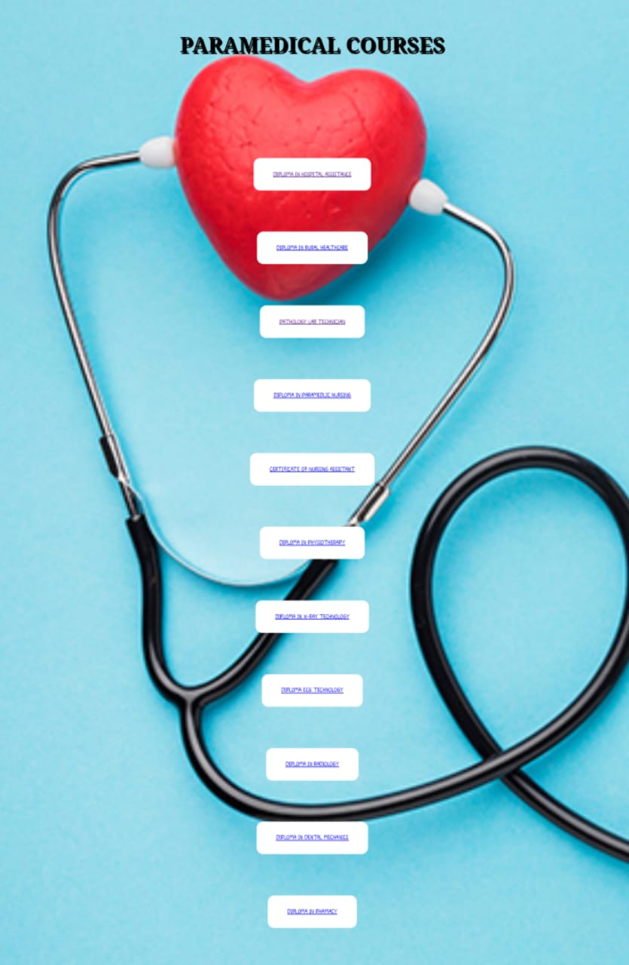

**CONCLUSION AND FUTURE SCOPE**

**CONCLUSION**

From the above stated information, it can be concluded that this CAREER DEVELOPMENT provides a quick and easy way through which students can quickly get good idea about course suggestions. Knowing how career development is important, and the fact that the system can be accessed easily on devices, after it has been deployed, ‘BE UNIQUE’ can reach a wider range of students, which creates a larger impact. Furthermore, since the application does not require a login and does not need the user to build an elaborate profile to get recommendations, the students can get accurate information immediately.

**LIMITATIONS**

The major limitation of this project is that the system can only give results if the student selects a course that is already present in our dataset.

**FUTURE SCOPE**

We would like to include a search bar that will make it easy for the students to search for a course in our dataset. In addition, we would like ‘BE UNIQUE’ to also be a mobile application to increase the accessibility of the system. Furthermore, we would like for students to be able to add new courses to our dataset so that our system will be able to recommend the newest of the newest courses. After implementing all these features, we would like to fully deploy the project so that it is accessible to everyone through the internet.

**BIBLIOGROPHY**

[Best High Salary Course for 12th Science PCM (amecee.in)](https://www.amecee.in/lp-12th-science-pcm-for-bright-career?utm_source=google&utm_medium=pcmcpc&utm_campaign=pcm_amecee&campaignid=19351256060&adgroupid=141992102342&device=m&gclid=Cj0KCQiAz9ieBhCIARIsACB0oGIOgw--q8N0PoOyr3n46OFike100ARlA9AqlrIMh4TJZN5U03v0vQUaAmVIEALw_wcB)

[MS Specializations in USA: What are the Best MS Courses in USA? | Yocket](https://yocket.com/blog/ms-specializations-in-usa)

[60+ Courses after 12th 2022 - Arts, Commerce & Science Students (careers360.com)](https://school.careers360.com/articles/courses-after-12th/amp)

[Best Career Options And Courses After 12th Arts in 2023 (mygreatlearning.com)](https://www.mygreatlearning.com/blog/career-options-after-12th-arts/#:~:text=The%20list%20for%20choosing%20courses,subject%20for%20yourself%20is%20important)

[Diploma Courses After Class 10th & 12th | Graduate Diploma Courses (myamcat.com)](https://www.myamcat.com/blog/featured/what-are-your-options-after-diploma/)

[Definition and advantages of vocational courses|Career (jagranjosh.com)](https://www.jagranjosh.com/articles/what-are-vocational-courses-and-how-can-they-help-you-in-career-1507208659-1)

[Polytechnic Courses after 10th and their Career Prospects (exambazaar.com)](https://www.exambazaar.com/blogpost/polytechnic-courses-after-10th)

[ITI's Radiology Technician/Radio Diagnosis & Radiotherapy in India, Radiology Technician/Radio Diagnosis & Radiotherapy trade/course details (targetstudy.com)](https://targetstudy.com/iti/trade/102-radiology-technician-radio-diagnosis-radiotherapy/)

**THANK YOU**